New phytogenic solution contributing to poultry fertility
Biostrong® Fertile – Efficiency in production of day-old chicks

Engerwitzdorf, March 30, 2022. As part of Delacon's phytogenic product line for poultry, Biostrong® Fertile represents proven natural fertility support for breeding flocks. The unique formulation was specially developed to enhance reproductive performance and control oxidative stress in breeding males. A comprehensive range of essential oils, flavonoids, and saponins, all obtained from natural sources, support the oxidative resilience of semen and its components and contribute to optimized hormonal processes.

With Biostrong® Fertile, Delacon offers a revolutionary natural solution to support the reproduction of breeding males, which increases the percentage of fertilized eggs. The formulation is based on extensive and deep knowledge in the universe of phytogenic active substances and their respective effects on the metabolism of farm animals. Phytogenic compounds can mitigate adverse oxidative effects since those substances can raise the sperm count and functionality and have a positive impact on reproduction. Improving males' fertility is the most efficient way to strengthen the production of day-old chicks.
Reduction of oxidative stress – a positive effect on semen

Sperm cells are sensitive to free radicals due to their significant content of lipids. This oxidative reaction may impact the morphology and functionality of the spermatozoa. Moreover, the free radicals can interfere with the DNA transported by the sperm cells, reducing the viability and quality of embryos and the offspring. Biostrong® Fertile is a unique and compelling contribution, helping to reduce oxidative stress in healthy breeding males, which can regulate testosterone production and semen quality parameters, thus indirectly contributing to the health of the reproductive performance level.

“Biostrong® Fertile is a tailored solution, addressing a primary customer need to optimize breeding flocks' fertility. Its technology is based exclusively on natural plant-derived compounds that enhance males’ healthy fertility, which is the most efficient way to strengthen the production of day-old chicks. The Delacon team is convinced of the effectiveness of Biostrong® Fertile to support producers in boosting the reproductive performance of their breeders' flocks.”, so Roberto Montanhini Neto, Global Unit Lead Monogastrics at Delacon.

Effect of Biostrong® Fertile on the semen
of broiler breeders
Study details available upon request

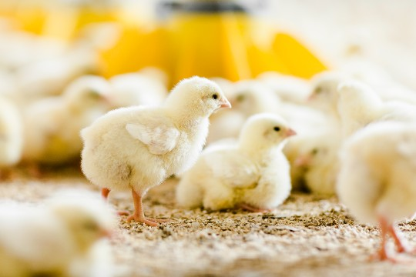
Caption: Biostrong® Fertile supports efficiency in production of day-old chicks. (© Delacon)

Effect of Biostrong® Fertile on the semen
of turkey breeders

Study details available upon request

