Delacon appoints Gina Medina as Sales Group Leader Asia
Gina Medina is new Delacon Sales Group Leader for Asia. She is now leading the entire sales team in the region. Within the last five years, Asia has become an important business for Delacon, having strong growth rates. Interest in phytogenic feed additives increases, and it shows: Profitability is not the only reason anymore to use them, consumer preferences matter today.
The animal nutritionist Gina Medina joined Delacon as Regional Technical Manager in 2010. She soon became a Regional Sales Manager and has initiated several business development projects and activities. In her new position as Sales Group Leader, Gina Medina is responsible for sales growth development and profitability. Moreover, she will implement business strategies and manage the Sales Country Managers, Regional Sales Managers, and distributors in Asia.
“Gina is an important talent of the company. I believe her leadership will strengthen our business and will bring more success stories in Asia,” says Markus Dedl, CEO.
The animal production landscape in Asia is changing. An increasing number of countries are banning antibiotic growth promoters. Recently, Vietnam and Indonesia (2018). “In my almost eight years at Delacon, I have witnessed the positive market acceptance and application of phytogenic feed additives in animal production,” says Gina Medina.
Consumer values are shaping the region
The International Feed Industry Federation (IFIF) announces: In 2050, the world demands about 60 percent more food – in a safe, nutritious, and sustainable way. Regional interests are also reflecting these global demands. A recent consumer survey in Thailand shows: Millennial foodies are ready to buy into the concept of natural animal feeding. Nine out of ten would want to know their meat is raised with phytogenic feed additives.
Animal producers respond to these interests, replacing antibiotic growth promoters. Together with her sales team and business partners, Gina Medina takes a meaningful stance on the company’s goals: “We will strengthen our presence and drive the business together in this fast-growing market. Our goal is to provide our customers and business partners natural products, proven and tested to be effective.”
Delacon – performing nature
Delacon coined the term ‘phytogenic feed additives,’ and has been the pioneer and global leader in this category for three decades. It invests ten percent of its annual turnover into research and development. The company continuously extends the product portfolio to serve market demands – such as heat stress and gut integrity.
Independent scientific institutions, such as the European Food Safety Authority (EFSA) confirm product safety and efficiency. For example, Fresta ® F and Biostrong® 510 EC are phytogenic feed additives that received the zootechnical registration.



Caption: Gina Medina announced as new Delacon Sales Group Leader Asia. © Delacon
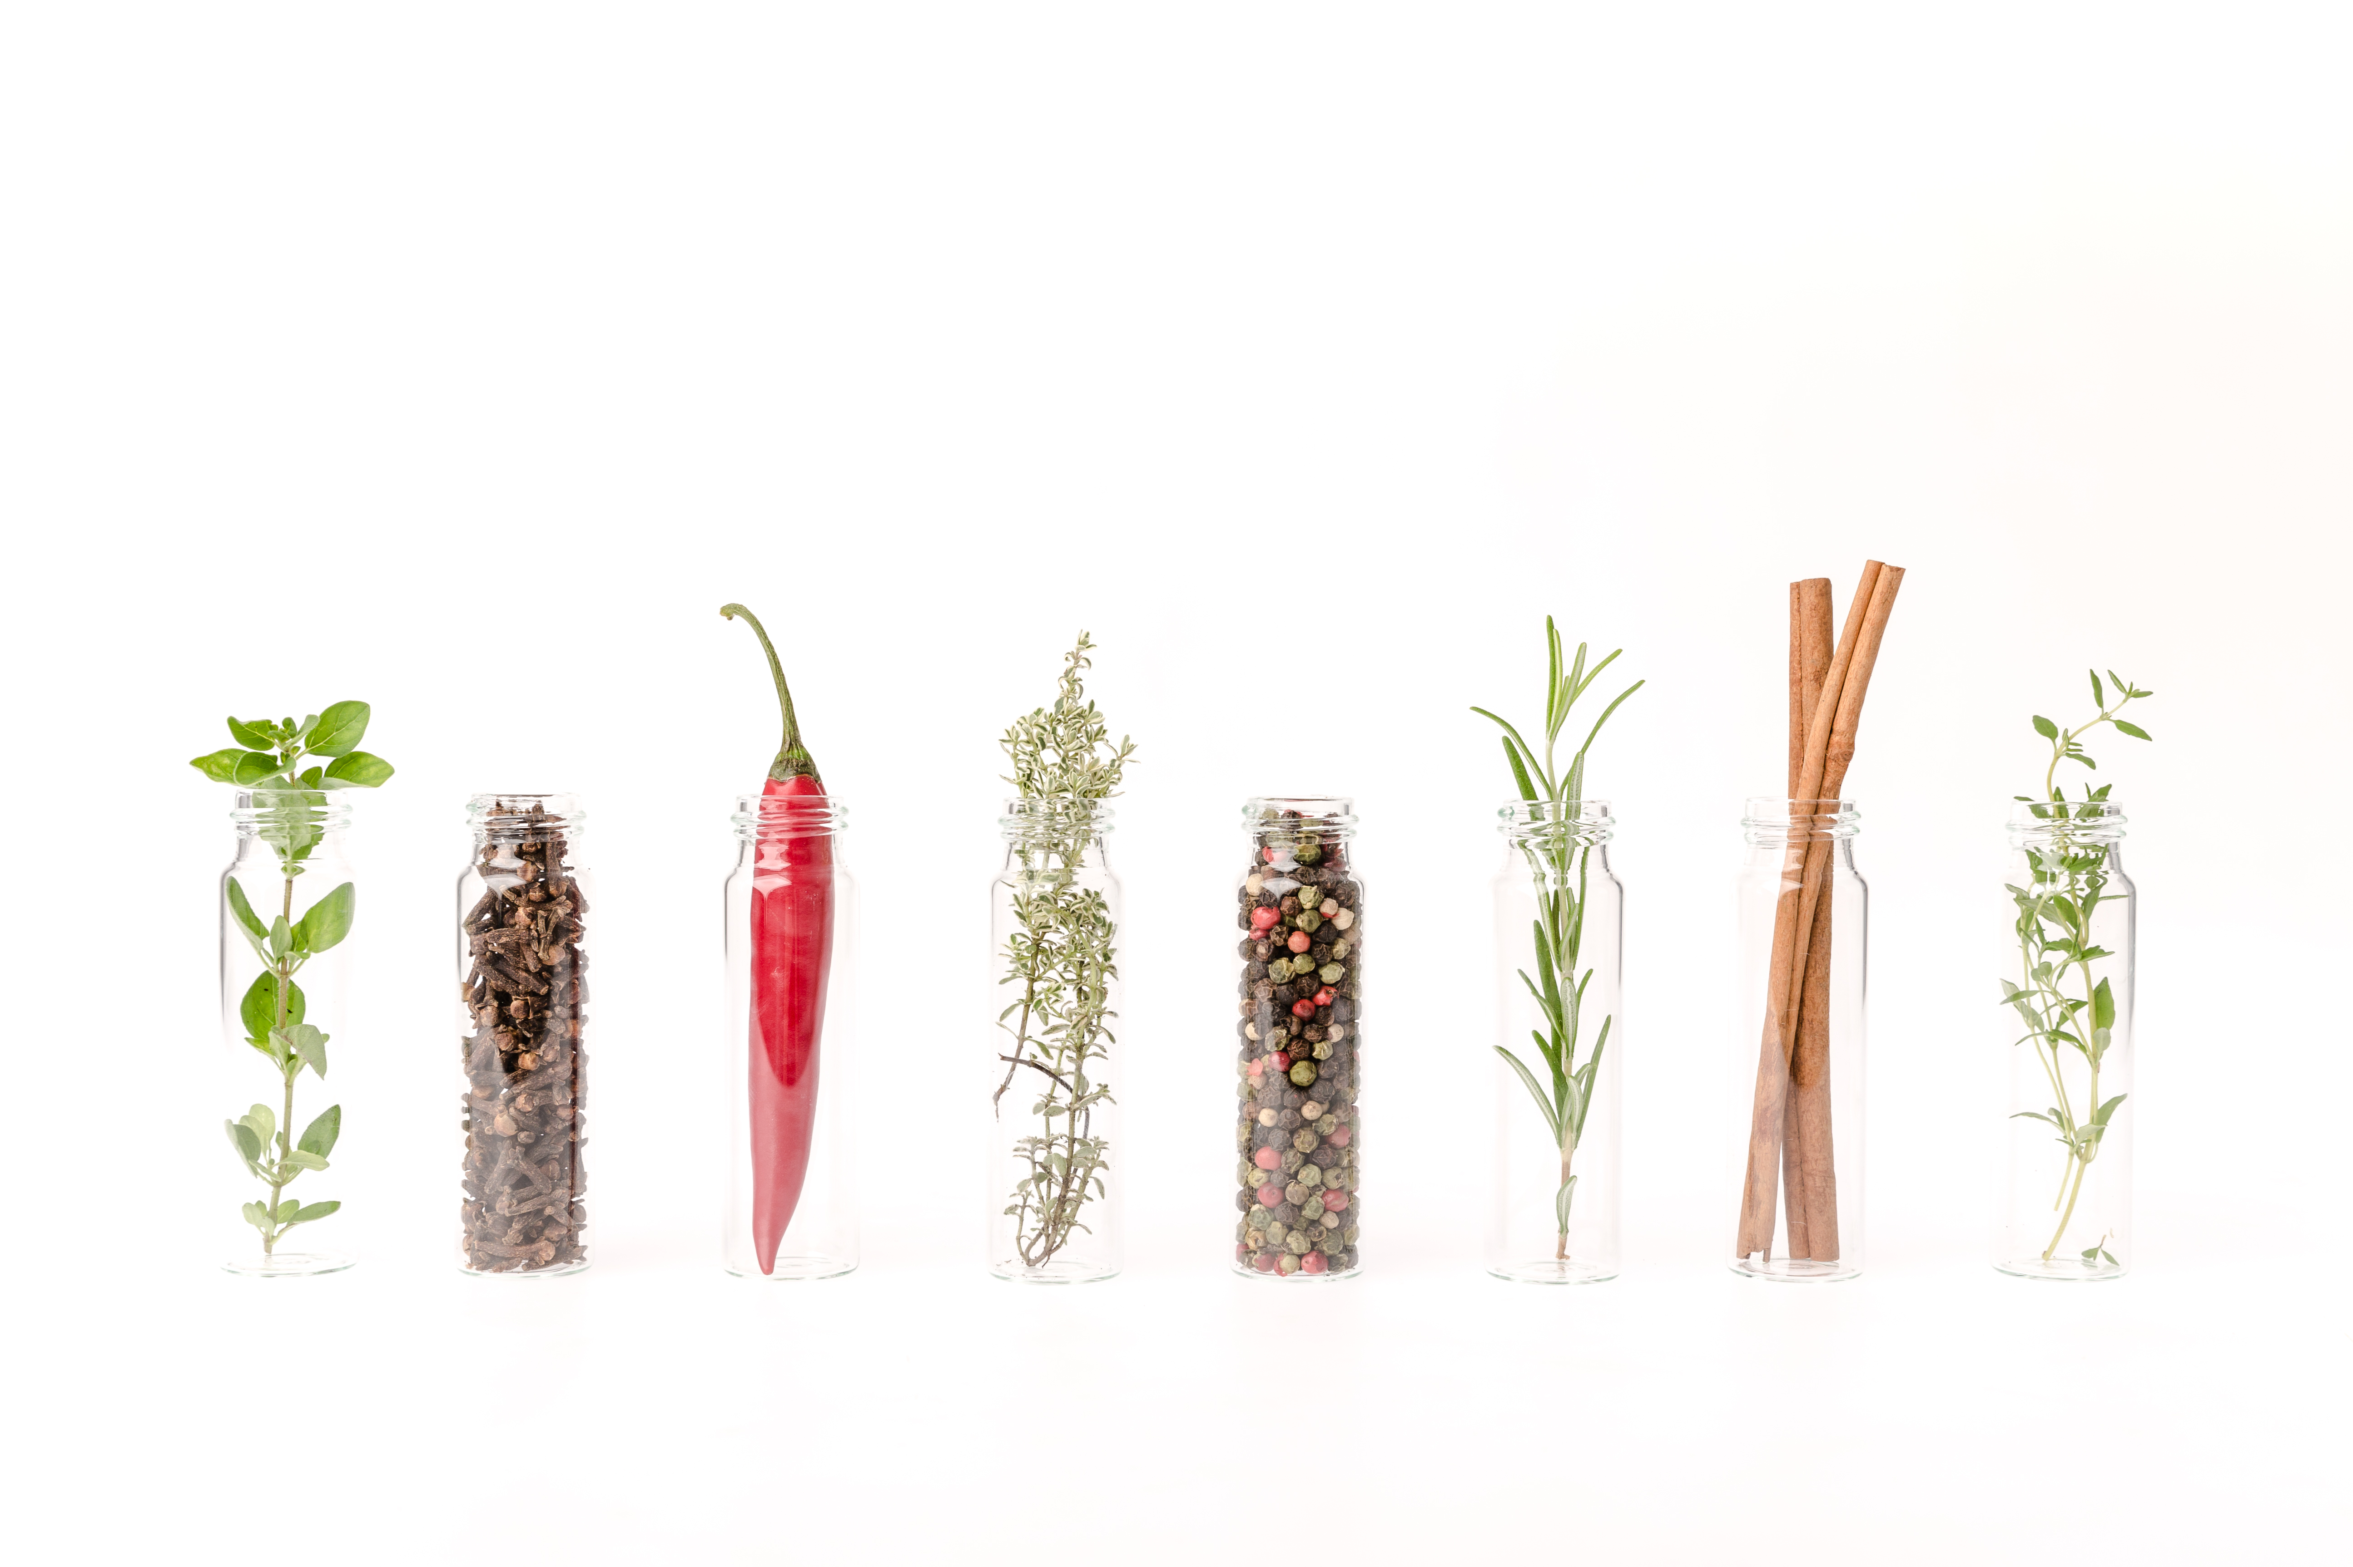

Caption: Phytogenic feed additives are more than just a combination of essential oils. © Delacon

