Positive EFSA opinion for the phytogenic feed additive Biostrong® 510

The European Food Safety Authority (EFSA) confirms safety and efficacy of Delacon’s phytogenic feed additive Biostrong® 510 for poultry

STEYREGG, Austria, July 11, 2016. On Friday, July 8, EFSA published its independent scientific opinion on Biostrong® 510 for poultry. It is positive and confirms the efficacy of Biostrong® 510 for chickens for fattening as well as safety for the target animals, consumers, and the environment. The opinion states that these conclusions can be extended to chickens reared for laying, and extrapolated to all minor poultry species (e.g. ducks, geese and quails) for fattening and reared to point of lay. The European Commission will evaluate the opinion and decide about the authorization of Biostrong® 510 as zootechnical feed additive.

Following Delacon’s request for an EU-authorization of Biostrong® 510 as zootechnical additive, the European Commission asked the EFSA-Panel on Additives and Products or Substances used in Animal Feed (FEEDAP) to evaluate and deliver an independent scientific opinion about the safety and efficacy of Biostrong® 510. This opinion was published on July 8, 2016.

Therein, the FEEDAP Panel concludes that Biostrong® 510 is safe for chickens for fattening at the proposed conditions of use. Moreover, it does not consider Biostrong® 510 used at the recommended levels to be a risk for the consumer of meat and meat products, nor for the environment. Furthermore, it considers that Biostrong® 510 has the potential to efficaciously improve performance of chickens for fattening. The Panel states that these conclusions can be extended to minor avian species for fattening as well as for chickens and minor avian species reared to point of lay.

“The positive scientific opinion of EFSA on Biostrong® 510 is another milestone for us as a pioneer and global market leader in phytogenic feed additives. Biostrong® 510 is one of our main products, thus we look forward to the decision of the European Commission on the zootechnical registration for this phytogenic feed additive”, explains Delacon’s CEO Markus Dedl. The EFSA opinion, an independent expert review of diverse studies submitted by Delacon, underlines that Biostrong® 510 is a science-based product – efficacy was proven on both improved zootechnical performance and better nutrient digestion.
Significant data confirms the efficacy of the hundreds of single components in Biostrong® 510
Biostrong® 510 is a preparation of partially micro-encapsulated essential oils from thyme and star anise, dried herbs and dried spices, fully using synergistic effects of different groups of active substances. As the product is a complex plant based product, providing hundreds of single compounds, EFSA was looking into the detailed composition of each ingredient, the constituents of essential oils, as well as all herbs & spices. Therefore, Delacon provided a lot of supplementary information as well as a vast number of significant studies and trials using a variety of different methods. These significant results support the EFSA’s evaluation of Biostrong® 510 as a digestibility and performance enhancer. Biostrong® 510 is available on a global scale.

More information will be provided as soon as the authorization details are available.

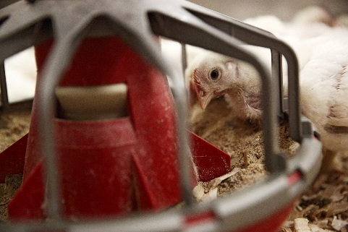

The EFSA confirms safety and efficacy of Delacon’s phytogenic feed additive Biostrong® 510 for poultry, improvement of zootechnical performance has been supported by diverse scientific data and verified by EFSA. (Photo: Delacon)

The European Food Safety Authority (EFSA) is the keystone of European Union (EU) risk assessment regarding food and feed safety. In close collaboration with national authorities and in open consultation with its stakeholders, EFSA provides independent scientific advice and clear communication on existing and emerging risks. EFSA is an independent European agency funded by the EU budget that operates separately from the European Commission, European Parliament and EU Member States.
About Delacon
Founded and grown as an Austrian family business, Delacon has been the pioneer and global leader in phytogenic feed additives for more than 27 years. The company researches, develops and produces natural feed additives composed of herbs, spices and essential oils for poultry, swine and ruminants, and coined the term ‘phytogenics’.
With 120 employees at 17 locations Delacon is consistently working on further expansion of its global leadership. In total Delacon's products are exported to about 80 countries. For years, the company realizes double-digit growth of revenues; ten percent of the annual revenues are invested in research and development.

For more information, please contact:
Karina Umdasch
PR & Communications Manager
Delacon Biotechnik GmbH
Weissenwolffstrasse 14, 4221 Steyregg, Austria
Tel +43 732 640 531-414
karina.umdasch@delacon.com
www.delacon.com

